Please have one person in your group answer each question. Decide how you want to split this up. Discuss your answers online in your group discussion thread. Combine all your answers in one document and include the name of the person who answered each question.

Due by Tuesday January 15, 10:00PM

Every group member must participate.

Section 1: Review Questions
1. Using this diagram answer the following questions
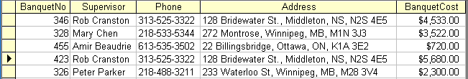

- Mary Chen leaves the company so we delete her record as we no longer are required to store her contact information. What problem might occur because of this deletion?
If we are to delete Mary Chen’s contact information, we will also remove information related to banquet 328 and its related cost. The user will also have to ensure that every tuple related to Mary is deleted from the table, which may result in further data loss in a table meant to store banquet data.

- To enable data independence how would you redesign this table?
To enable data independence, put the supervisor’s name, phone number, and address in a separate ‘Employee’ table and assign each employee a primary key. The Banquet table would have ‘BanquetNo’ as a primary key, ‘BanquetCost’ as an attribute, and a foreign key referencing the supervisors’ primary keys in the ‘Employee’ table. This way, any addition or update in one table would not affect the other.

2. How does a relational database ensure data integrity?
The RDBMS is the mechanism that enforces data integrity in a relational database. It uses logically related entities, attributes, and relationships to ensure both data integrity and data independence, hence values can be inserted, deleted, and updated without affecting other records and duplications are avoided.

3. What is a file based data management system and in your own words describe problems associated with it.

A file based data management system is a series of files. Each file contains a set of related records. These files may be stored in different formats and their relationships with each other may not have any well defined restrictions. Due to different file formats, building relationships among different sets of records may be difficult. Inserts, updates, or deletes performed in one file must be replicated in all other files with similar attributes, (e.g. names, addresses). This may lead to data duplication and inconsistencies within the database.

4. In your own words explain the difference between data and information?

Data are raw facts. Ie. Color, size, price. Information is a set of data that is organized and formatted to support decision making.

Section 2: Prep Questions for Next Week (Please look up on the internet)
- What is a CHEN ERD? Show a small diagram and describe it in 8 lines or less (or lose marks)
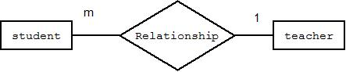
A Chen ERD is a type of Entity Relationship Diagram. It is the first popular method that was used to describe relationships between tables and it has since taken similar forms such as Crow-foot and UML notations. The Chen ERD shows the relationship between entities (tables) which are denoted by rectangles. A diamond shape describes the relationships. Letters and numbers denote the cardinality of the relations (ie. One to one, one to many, many to many). In this example, the Chen ERD shows a teacher that has many students but each student has only one teacher.

- What is a crow foot diagram? Explain in 5 lines or less (or lose marks) Show a small diagram for a one to one relationship, a one to many relationship, and a many to many relationship.

A crow foot diagram represents relations between entities. It uses lines to join entities and notation to represent the cardinality in the relationship. Cardinality may include (but is not limited to) the following: one to one, one to many, and many to many as shown in the diagram below. Cardinality may also include optional denoted by an empty circle.
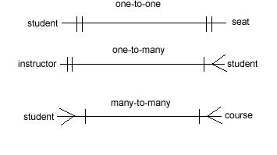
- Describe the following keys (3 lines or less for each or lose marks)
  - What is a primary key?
A primary key is an attribute (column) or set of attributes that are in minimal form and must uniquely identify each row in a table.

  - What is a candidate key?
A table might have several potential primary keys. Ie. A person’s profile in a British Columbian medical database might have their social insurance number and their care card number stored there as attributes. Both attributes are candidates to be primary keys but in the end only one primary key can be selected. In short, a candidate key is a potential primary key.

  - What is a foreign key?
A foreign key is an attribute or a set of attributes in a table that match the primary key of another table. In a relational database system this relationship between primary and foreign keys ensures referential integrity. A table may have more than one instance of a foreign key. Foreign keys may be null (empty).

- What is referential integrity?
Referential integrity ensures that relationships between tables are consistent. Links are created between primary keys and foreign keys.

- What is entity integrity?
Entity integrity ensures that no records are duplicated. It is enforced by ensuring that primary key attribute values are unique and not null.

- Define: (3 lines or less for each or lose marks)
  - Entity
An entity is a table that defines a set of related attributes. Ie. A student table might store last name, first name, student number, etc. Each row of data is a unique instance of the entity.

  - Attribute
Attributes are details or columns of an entity.

  - Row (Sometimes called record)
A row is a set of attributes. Each row is a unique instance in an entity.

